📘 PROJECT REPORT
Behavioural Alpha Trading System Using NLP and Fear & Greed Index

1. INTRODUCTION
In modern financial markets, price movements are not driven only by technical indicators and fundamentals, but also by human emotions and market psychology. Fear and greed play a major role in market movements. With the rise of social media, financial news platforms, and real-time data, it has become possible to capture and quantify sentiment using Natural Language Processing (NLP).
This project titled “Behavioural Alpha Trading System (NLP + Fear & Greed Index)” is designed to:
- Analyse market sentiment using NLP,
- Combine it with a Fear & Greed Index (FGI),
- Generate automated BUY / SELL / HOLD trading signals,
- Display the results in a real-time Streamlet dashboard.
This system demonstrates how behavioural finance and artificial intelligence can be combined to build smart trading tools.

2. OBJECTIVES OF THE PROJECT
The main objectives of this project are:
- To collect live stock market price data.
- To perform sentiment analysis using NLP.
- To compute the Fear & Greed Index (FGI).
- To generate automated trading signals.
- To store all results in an SQLite database.
- To display real-time data using a web-based Streamlet dashboard.
- To build a complete working NLP-based trading system.

3. LITERATURE REVIEW (BRIEF)
Traditional trading systems rely mainly on:
- Technical indicators like RSI, MACD.
- Fundamental analysis using balance sheets.
However, modern research shows that:
- Market sentiment strongly impacts price movements.
- NLP can be used to analyse news and social media feeds.
- The Fear & Greed Index is widely used to measure investor emotions.
This project combines NLP, sentiment analysis, behavioural finance, and algorithmic trading into one integrated system.

4. SYSTEM ARCHITECTURE
The system consists of the following modules:
- Data Ingestion Module
  - Collects live stock prices
  - Fetches news headlines
- NLP Sentiment Engine
  - Performs text analysis
  - Uses mock sentiment / Fin BERT-ready logic
- Fear & Greed Index (FGI) Module
  - Generates a numeric value based on sentiment and price behaviour
- Signal Generation Engine
  - Produces BUY / SELL / HOLD signals
- Database Module (SQLite)
  - Stores sentiment, FGI, and signals
- Web Dashboard (Streamlet)
  - Displays live data visually in browser

5. TECHNOLOGIES USED
- Python – Core programming language
- NLP (Natural Language Processing)
- Streamlet – Web dashboard
- SQLite – Database
- Pandas & NumPy – Data handling
- Yahoo Finance API (finance) – Live stock data
- Ngok – Public URL hosting
- Google Colab – Cloud-based execution
- GitHub – Version control

6. PROJECT FEATURES
- Real-time stock price fetching
- NLP-based sentiment analysis
- Fear & Greed Index computation
- Automated trading signals
- SQLite database storage
- Interactive Streamlet dashboard
- Public access using Ngok
- Modular Python architecture
- Works on both Colab and local system

7. PROJECT WORKFLOW
- User starts the system.
- Stock price is fetched in real-time.
- News headlines are analysed using NLP.
- Sentiment score is calculated.
- Fear & Greed Index is computed.
- Trading signal is generated.
- All data is stored in database.
- Dashboard displays live results.

8. PROJECT STRUCTURE
behavioral_alpha/
│
├── ingestion/
│ ├── price_feed.py
│ └── news_feed.py
│
├── nlp/
│ └── sentiment_engine.py
│
├── indicators/
│ └── fgi.py
│
├── signals/
│ └── signal_engine.py
│
├── database/
│ ├── db.py
│ └── models.py
│
├── dashboard/
│ └── app.py
│
└── main.py

9. OUTPUT & RESULTS
- The system successfully generates HOLD signals for stocks like:
  - AAPL
  - AMD
  - NVDA
  - TSLA
- The Streamlet dashboard shows:
  - Live prices
  - Sentiment
  - Fear & Greed Index
  - Trading signal
✅ Live Demo Link:
https://overbulkily-uncompulsory-mireille.ngrok-free.dev/
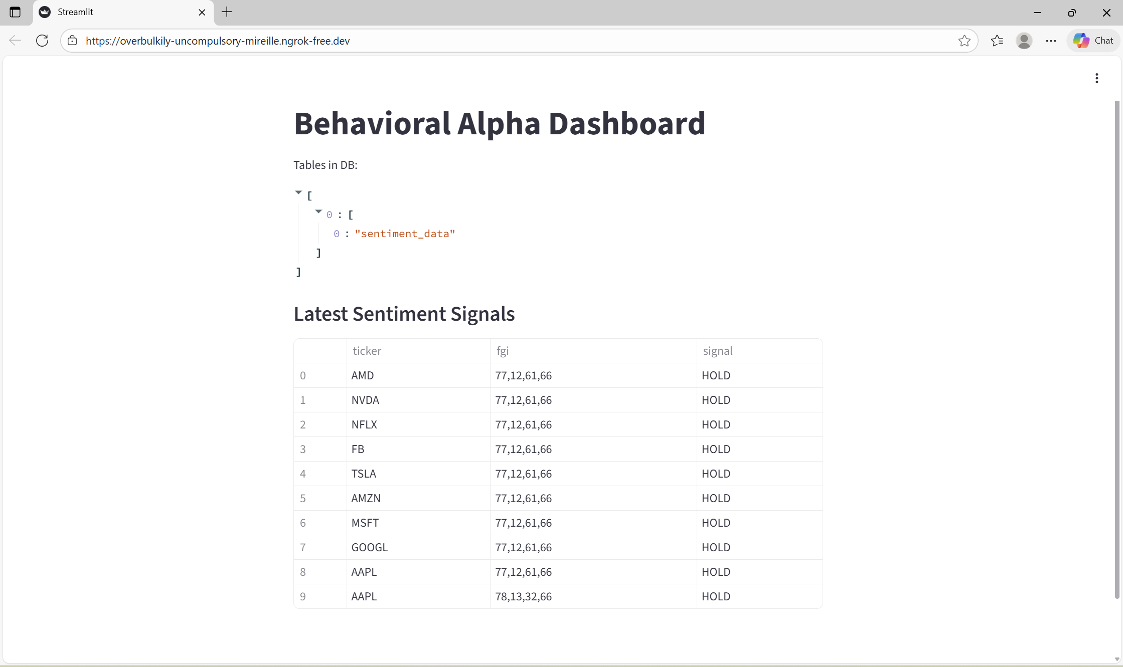

10. ADVANTAGES
- Real-time signal generation
- Emotion-based trading logic
- Automated decision-making
- Easy-to-use dashboard
- Cloud-compatible
- Can be upgraded with real Fin BERT model

11. LIMITATIONS
- Current sentiment engine uses mock logic
- Fear & Greed Index is simplified
- Works best for educational and demo purposes
- Live Ngok link is temporary

12. FUTURE SCOPE
- Integration of real Fin BERT / FinGPT
- Live Twitter & Reddit sentiment
- Reinforcement-learning-based trading
- Broker integration for automatic trades
- Cloud deployment with permanent domain

13. APPLICATIONS
- Algorithmic trading
- Behavioural finance research
- Portfolio management tools
- Market analysis platforms
- AI-based financial systems

14. CONCLUSION
This project successfully demonstrates how NLP, market psychology, and real-time data can be combined to build an intelligent trading signal generation system. The Behavioral Alpha Trading System proves that sentiment-based trading strategies can be automated and visualized using modern tools like Python and Streamlet.
The system is scalable, modular, and suitable for future enhancements.

15. DISCLAIMER
This project is strictly for educational and research purposes only.
It does not provide financial advice.
Trading in financial markets involves high risk.

